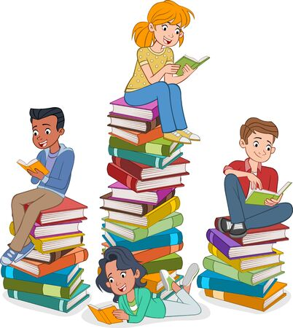


What We Read at School

When children are first learning to blend sound into words, they will take home each week:
- The sounds they have learned in Read Write Inc.
- A picture book to discuss and talk about
- Words to practise ‘Fred Talking’/blending using the sounds they have learned at school (green words)

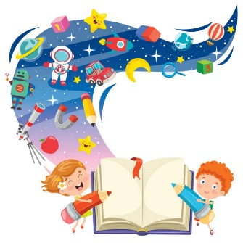
Once children can ‘Fred Talk’ and blend sound into words, they will take home:
- A photocopiable ‘ditty’ or page with short captions
- The sounds they have learned in Read Write Inc.
- A blending book with the sounds they are mastering

Once the children have progressed to red books and beyond, they have access to at least three books to read at home each week. These are:
- Their Read Write Inc. book they have read in their reading sessions, sometimes referred to as ‘floppy copies’. This should be fully decodable.
- A matched Read Write Inc. book bag book from their current level. This is also fully decodable.
- A ‘richer read’ book that provides an additional challenge that can be read to or with the child. This book may not be fully decodable.
When children can read at a consistent pace (approximately 90+ words per minute) and understand what has been read, they will graduate Read, Write Inc. and move onto levelled books in the Oxford Reading range. They will then change their reading book as regularly as they would like and will continue to be assessed regularly to ensure there is sufficient challenge in their reading material.

