Glossary
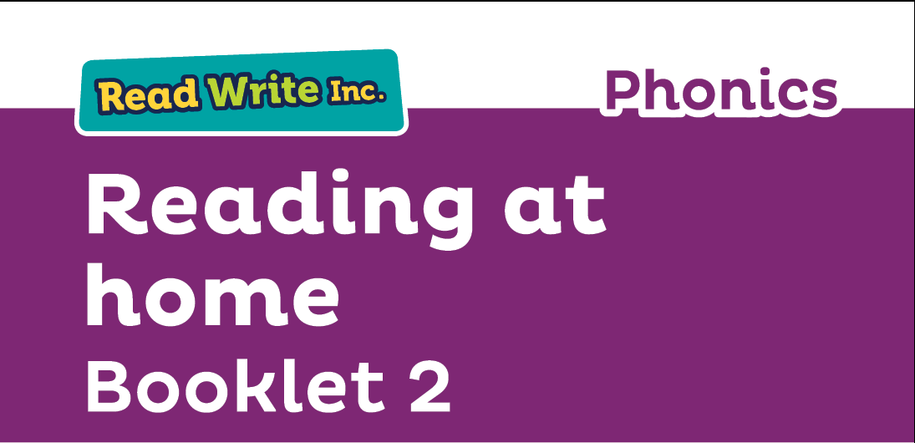
Fred Talk – sounding out the word before reading (blending)

sound-blending – putting sounds together to make a word,
e.g. c–a–t cat

special friends – two or three letters that make one sound,
  - sh, ng, qu, ch

Speed Sounds – the individual sounds that make up words

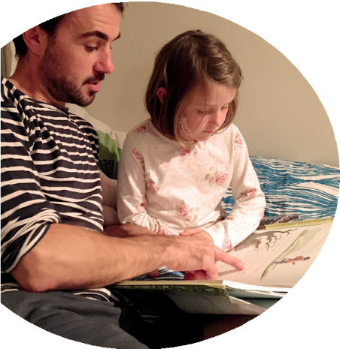
Read stories to your child with feeling! The more you love the story, the more your child will love reading.

Your child is learning to read with Read Write Inc. Phonics, a very popular and successful literacy programme. This booklet shows you how you can get your child off to a quick start.

Your child will learn to read in a very simple way. They will learn to:
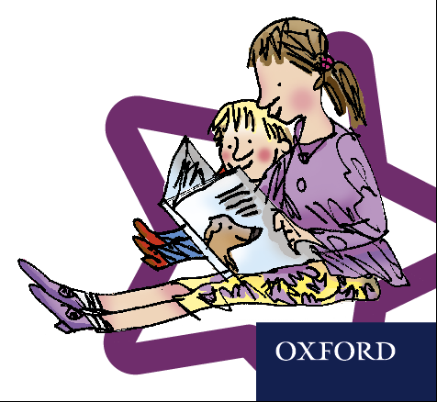
- Read letters by their ‘sounds’

Blend these sounds into words
- Read the words in a story.

www.ruthmiskin.com/parents has many videos to help you help your child.


For more information on Read Write Inc., please talk to the Read Write Inc. manager in your child’s school or visit www.readwriteinc.com.

8

How will my child learn to read?

Your child will learn to read:
Black and White Storybooks
Your child will bring home a Read Write Inc.
Phonics black and white Storybook.
This is a copy of the colour version they are
reading at school. An explanation of how to
follow the activities is included in the books.
Books are to be re-read repeatedly to build fluency and reduce the need to ‘sound out’ or ‘Fred Talk’ every word.

Book Bag Books
Your child may also bring home a Book Bag Book. This book builds upon the ideas and many of the words in the Storybook he or she has just read. Your child will need more support in reading this book.
Again, explanations of how to use the activities are included in the books. 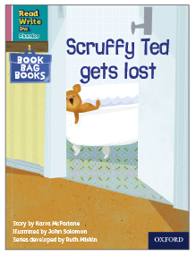 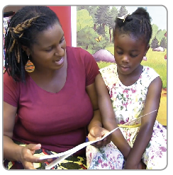

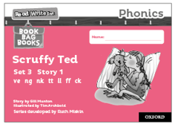
- Set 1 Speed Sounds: these are sounds written with one letter:
m a s d t i n p g o c k u b f e l h r j v
y w z x and sounds written with two letters • (your child will call these ‘special friends’): sh th ch
qu ng nk ck
- Words containing these sounds, by sound-blending,
- Set 2 Speed Sounds: ay ee igh ow oo oo ar or air ir ou oy
- Words containing these sounds
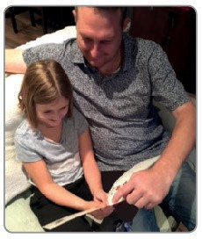
Next, they will learn to read:
- Set 3 Speed Sounds: ea oi a-e i-e o-e u-e aw are ur er ow ai oa ew ire ear ure and words containing these sounds

Listening to your child read
- Find a quiet, comfortable space to read every day.
- Read the guidance inside the front cover of the book first.
- Ask your child to read the sounds and words over the next few pages before they read the story. This will help them spot the words in the book.
- When your child reads the story, ask them to ‘Fred Talk’ the words that they can’t read automatically. Tell your child the word if they struggle. Praise your child when they succeed.
- Red words should be red on sight – if they don’t know the word, then please tell them.
- Read back each sentence or page to keep the plot moving. (Your child’s energy is going into reading the words not the story.) On each re-reading they will become more fluent.
- Have fun and enjoy spending this special time together.
We have a story time every day at school so children develop a love of stories. We hope that you will do the same by reading a bedtime story to your child every night. We have wonderful books in our school library for them to borrow too.

